|  |
| --- |
| **Argentis Consulting** |
| **Apparel & Footwear** |
| DTW - Data Migration |



**www.sapapparel.com**

**INDEX**

1.1 INTRODUCTION 3

1.2 TEMPLATES 3

1.2.1 Templates related to Styles 3

1.2.1.1 Relevant templates 3

1.2.2 Template: ARGNS_MODEL - ARGNS_MODEL 3

1.2.3 Template: ARGNS_MODEL - ARGNS_MODEL_COLOR 4

1.2.4 Template: ARGNS_MODEL - ARGNS_MODEL_SIZE 5

1.2.5 Template: ARGNS_MODEL - ARGNS_MODEL_VAR 5

1.3 DATA IMPORT PROCESS 6

1.3.1 Excel Preparation 6

1.3.1.1 Create the A&F segmentations 6

1.3.1.2 Master Data 7

1.3.1.2.1 Color Master 7

1.3.1.2.2 Scale & Size Master 8

1.3.1.2.3 Variable Master Data 8

1.3.1.2.4 Model Master Data 10

1.3.1.2.4.1 Model 10

1.3.1.2.4.2 Model – Color 11

1.3.1.2.4.3 Model – Sizes 12

1.3.1.2.4.4 Model – Variable 13

1.3.1.2.5 OITM – Items 13

1.3.1.2.5.1 Complete Items Code and Description 13

1.3.1.2.5.2 Relate Color, Model, Segmentation 14

1.3.1.2.5.3 Relate Scale, Sizes, Variable 15

1.3.2 CSV files import trough DTW – Data Transfer Workbench 15

## INTRODUCTION

This document contains the necessary information to prepare and execute data migration for Styles, Colors, Scale & Sizes, Variables and SKU’s (SAP Items) using the DTW tool.

## TEMPLATES

### Templates related to Styles

To import data related to Styles the following Excel templates need to be completed:

1. ARGNS_MODEL - ARGNS_MODEL
2. ARGNS_MODEL - ARGNS_MODEL_BOM
3. ARGNS_MODEL - ARGNS_MODEL_COLOR
4. ARGNS_MODEL - ARGNS_MODEL_CS
5. ARGNS_MODEL - ARGNS_MODEL_FILE
6. ARGNS_MODEL - ARGNS_MODEL_FITT
7. ARGNS_MODEL - ARGNS_MODEL_IMG
8. ARGNS_MODEL - ARGNS_MODEL_INST
9. ARGNS_MODEL - ARGNS_MODEL_LOGOS
10. ARGNS_MODEL - ARGNS_MODEL_SIZE
11. ARGNS_MODEL - ARGNS_MODEL_VAR
12. ARGNS_MODEL - ARGNS_MODELPOM
13. ARGNS_MODEL - ARGNS_MODELWFLOW

#### Relevant templates

From these Excel templates, the relevant ones for this example are the following:

1. ARGNS_MODEL - ARGNS_MODEL
2. ARGNS_MODEL - ARGNS_MODEL_COLOR
3. ARGNS_MODEL - ARGNS_MODEL_SIZE
4. ARGNS_MODEL - ARGNS_MODEL_VAR

The rest of the Excel templates will be necessary during the DTW import process but can be left blank.

All these Excel templates contain a number of columns, each one corresponding to a specific field in the database, which might or might not be necessary to complete with data.

### Template: ARGNS_MODEL - ARGNS_MODEL

This is the template that will hold the general information for each style at a header level.

The relevant fields in this template are:

1. Code: SAP Internal Code. This code is a sequence starting from 1. It must be unique.
2. U_ATGrp: A&F Segmentation group. This is the internal code corresponding to the segmentation code selected for each style.
3. U_ModCode: Style Code. This code MUST be unique and must correspond to a unique Code (SAP Internal Code)
4. U_ModDesc: Style Description
5. U_InvItem: Are the SKUs related to this style, stock items? (Default value: Y)
6. U_SalItem: Are the SKUs related to this style, sale items? (Default value: Y)
7. U_PurItem: Are the SKUs related to this style, Purchase items? (Default value: Y)
8. U_Year: Year code
9. U_Active: Define the style as Active (Default value: Y)
10. U_SapGrp: SAP Item Group code
11. U_PList: SAP Price list code
12. U_Division: Division code
13. U_Season: Season code
14. U_FrgnDesc: Foreign Description
15. U_ModGrp: Product Group code
16. U_SclCode: Scale code (for each size scale related to the style separated by comma)
17. U_LineCode: Product Line Code
18. U_MainWhs: SAP main warehouse code
19. U_Approved: Style approval (Default value: Y)
20. U_CollCode: Collection code
21. U_AmbCode: Sub-collection code
22. U_Brand: Brand code
23. U_Designer: SAP designer code
24. U_Status: Status code
25. U_SkuGen: Are there any SKUs related to this style? (Default value: Y)

Notes:

1. There will be one line per style
2. A **code** must be used for each of the fields that are related to other objects. i.e. For years, enter the Year code defined in SAP. For Seasons, enter the season code defined in SAP.
3. These **codes** must exist previously in SAP otherwise errors might come up during the data import process.

### Template: ARGNS_MODEL - ARGNS_MODEL_COLOR

This template holds the colors related to each style, this is where the actual Style Color relation gets created.

The relevant fields in this template are:

1. ParentKey: This is the SAP internal code defined in the code field of the ARGNS_MODEL - ARGNS_MODEL template.
2. LineNum: Leave blank. This field is automatically completed by DTW during the import process.
3. Code: This is the SAP internal code defined in the code field of the ARGNS_MODEL - ARGNS_MODEL template. Same as ParentKey
4. U_ModCode: Style code (defined in the U_ModCode field of the ARGNS_MODEL - ARGNS_MODEL template)
5. U_ColCode: Color code. From the color master data
6. U_Active: Is this color in use for this style? (Default value: Y)

Notes:

1. There will be one line per color per style
2. The color **code** must exist in the color master data table.
3. The ParentKey and Code will always have the same value
4. ParentKey, Code and Style code (U_ModCode) must exist in the ARGNS_MODEL template.

### Template: ARGNS_MODEL - ARGNS_MODEL_SIZE

This template holds the sizes associated to each style, this is where the actual Style Size relation gets created.

The relevant fields in this template are:

1. ParentKey: This is the SAP internal code defined in the code field of the ARGNS_MODEL - ARGNS_MODEL template.
2. LineNum: Leave blank. This field is automatically completed by DTW during the import process.
3. Code: This is the SAP internal code defined in the code field of the ARGNS_MODEL - ARGNS_MODEL template. Same as ParentKey
4. U_ModCode: Style code (defined in the U_ModCode field of the ARGNS_MODEL - ARGNS_MODEL template)
5. U_SizeCod: Size code from the Scales master data
6. U_Selected: Is this size in use for this style? (Default value: Y)
7. U_SclCode: Scale code from the Scales master data
8. U_VOrder: Visual order defined for the size.

Notes:

1. There will be one line per size per style
2. The Size **code** must exist in the scale master data table.
3. The Scale **code** must exist in the scale master data table.
4. The ParentKey and Code will always have the same value
5. ParentKey, Code and Style code (U_ModCode) must exist in the ARGNS_MODEL template.

### Template: ARGNS_MODEL - ARGNS_MODEL_VAR

This template holds the variables associated to each style, this is where the actual Style Variable relation gets created.

The relevant fields in this template are:

1. ParentKey: This is the SAP internal code defined in the code field of the ARGNS_MODEL - ARGNS_MODEL template.
2. LineNum: Leave blank. This field is automatically completed by DTW during the import process.
3. Code: This is the SAP internal code defined in the code field of the ARGNS_MODEL - ARGNS_MODEL template. Same as ParentKey
4. U_ModCode: Style code (defined in the U_ModCode field of the ARGNS_MODEL - ARGNS_MODEL template)
5. U_VarCode: Variable code from the variables mater data
6. U_IntVCode: Numeric sequence starting from 1
7. U_Selected: Is this variable in use for this style? (Default value: Y)
8. U_VarDesc: Variable Description. From the description field on the variable master data.

Notes:

1. There will be one line per variable per style
2. The Variable **code** must exist in the variable master data table.
3. The ParentKey and Code will always have the same value
4. ParentKey, Code and Style code (U_ModCode) must exist in the ARGNS_MODEL template.

## DATA IMPORT PROCESS

### Excel Preparation

#### Create the A&F segmentations

Before preparing the excel files remember to create through the B1 Client the A&F segmentations needed for the styles to be imported. The Internal code will be needed to fill some columns in i.e. Style Master, OITM – Items Master, Scale Master.

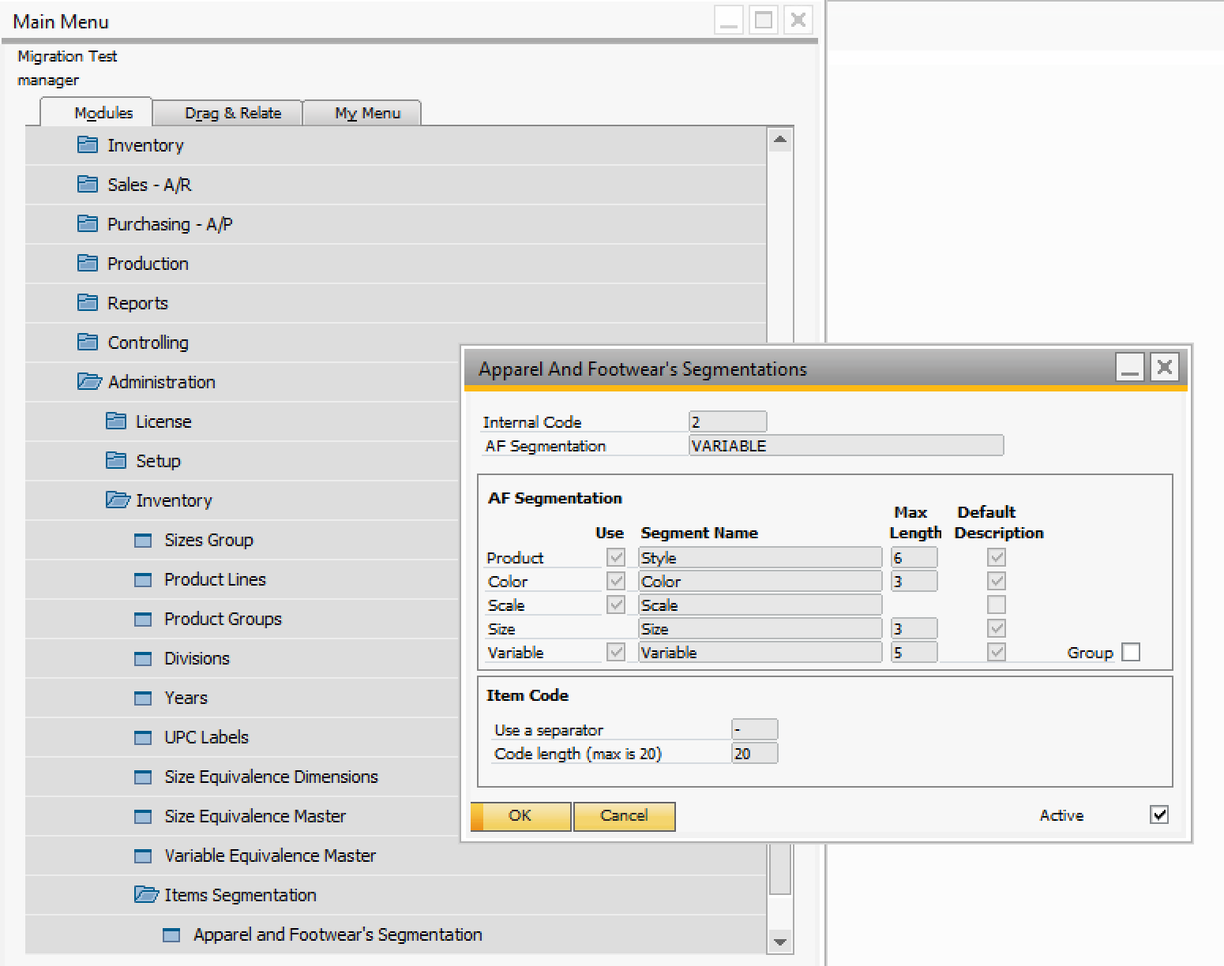

#### Master Data

After you populate the excel files with all the data, remember to save them as a .csv file (coma separated)

##### Color Master

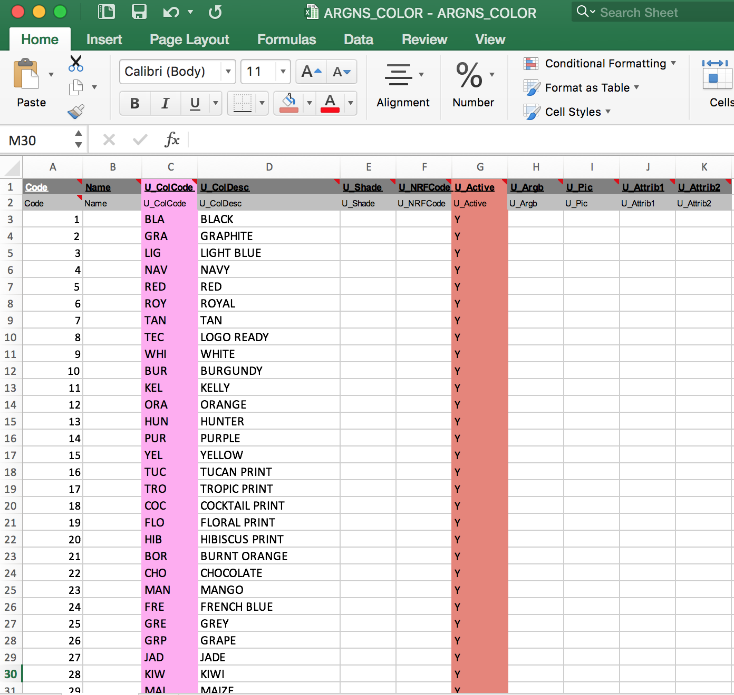

Notes:

1. If you want the color to be active check that the the following column is “Y”

|  |
| --- |
| **U_Active** |
| U_Active |
| Y |

##### Scale & Size Master

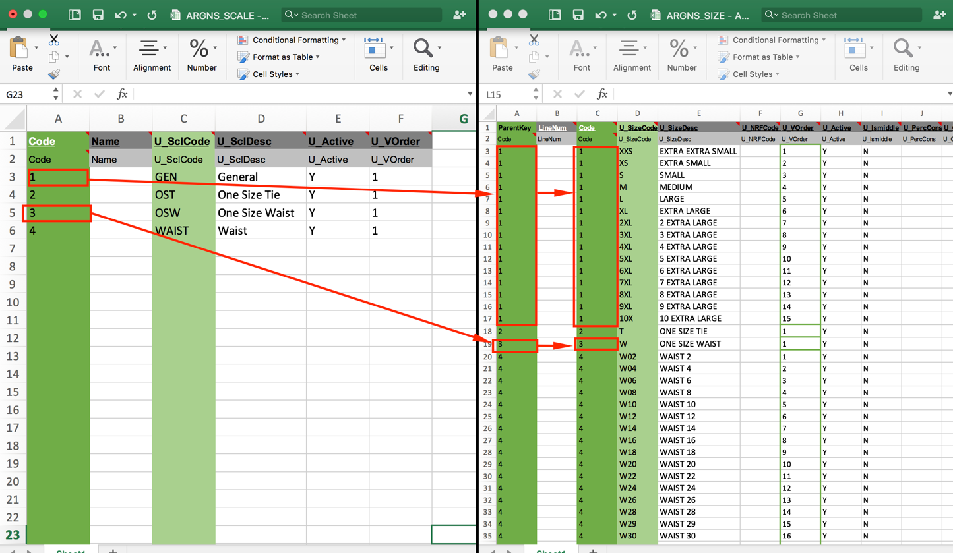

Notes:

1. If you want the scale and sizes to be active check that the the following column is “Y” in both files.

|  |
| --- |
| **U_Active** |
| U_Active |
| Y |

##### Variable Master Data

In case your styles need the variable attribute complete this file.

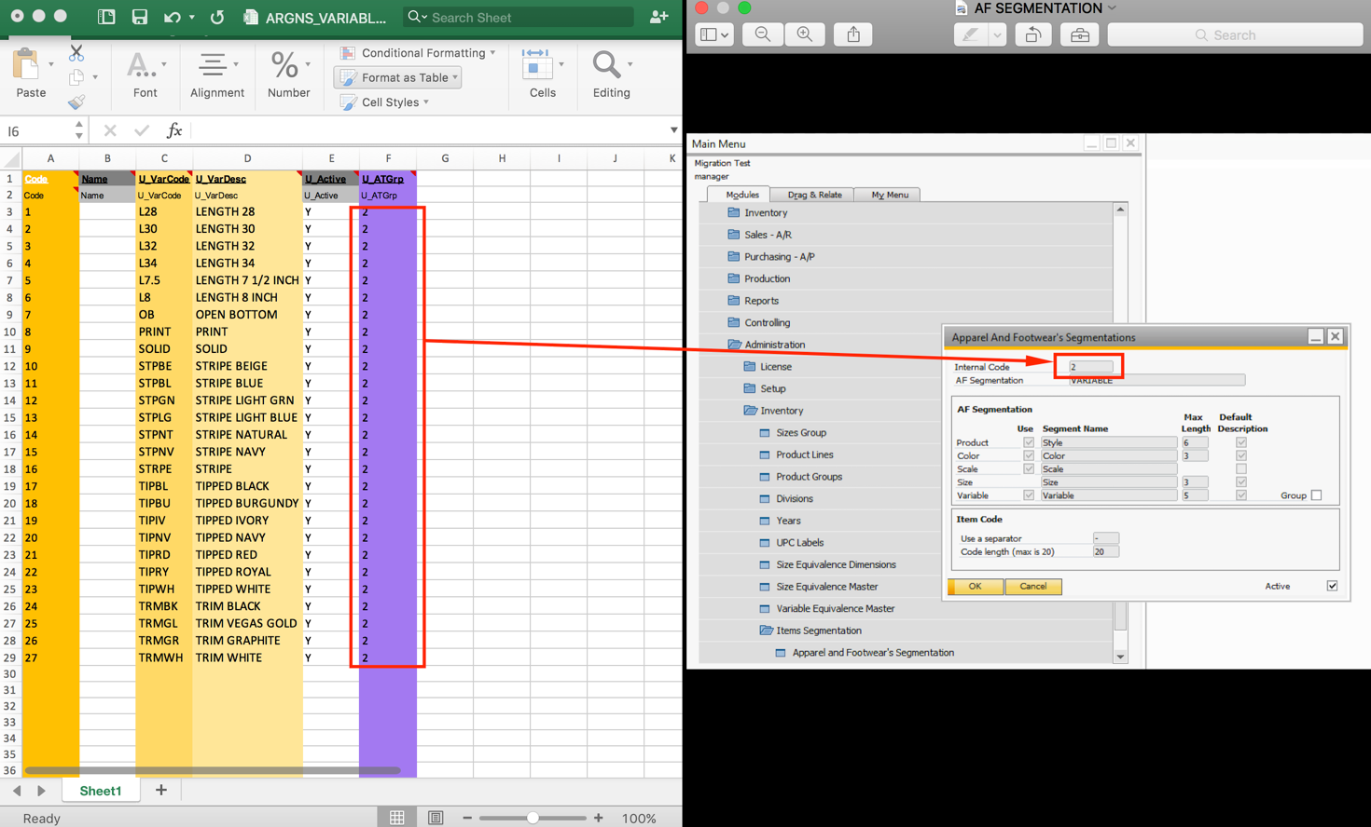

Notes:

1. If you want the variable to be active check that the the following column is “Y”

|  |
| --- |
| **U_Active** |
| U_Active |
| Y |

##### Model Master Data

###### Model

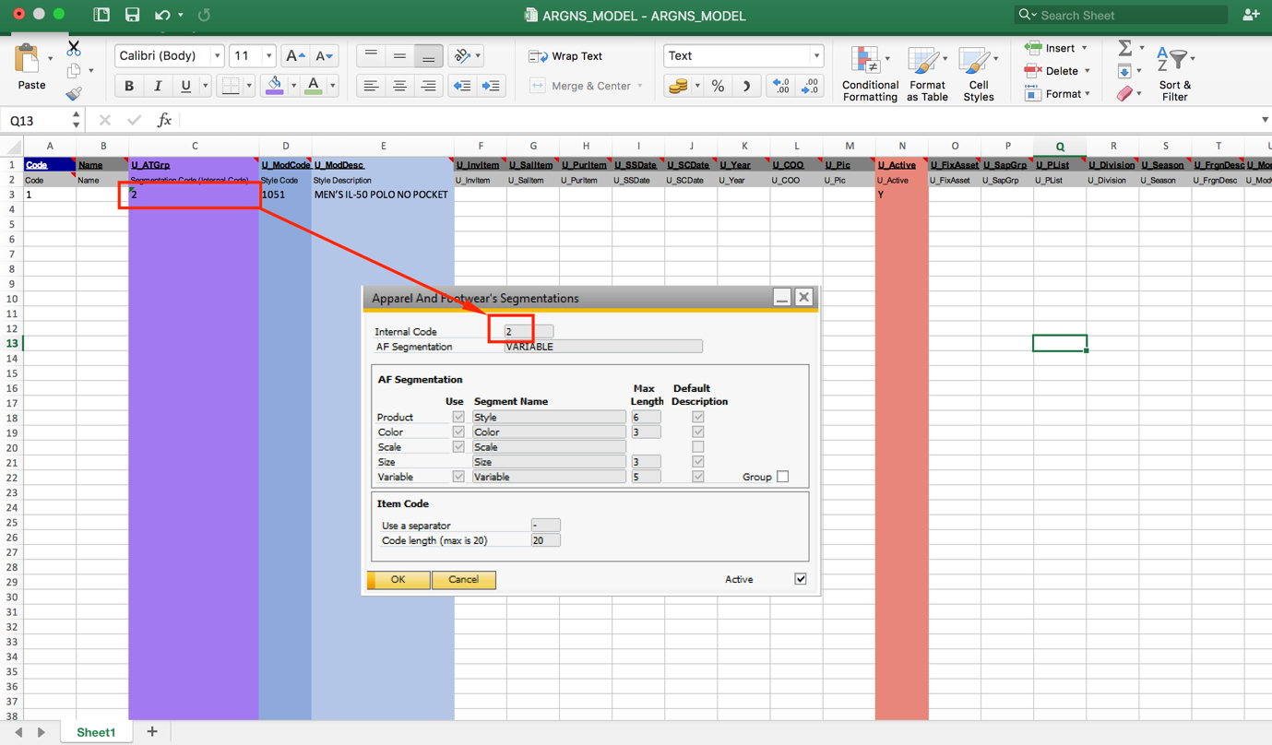

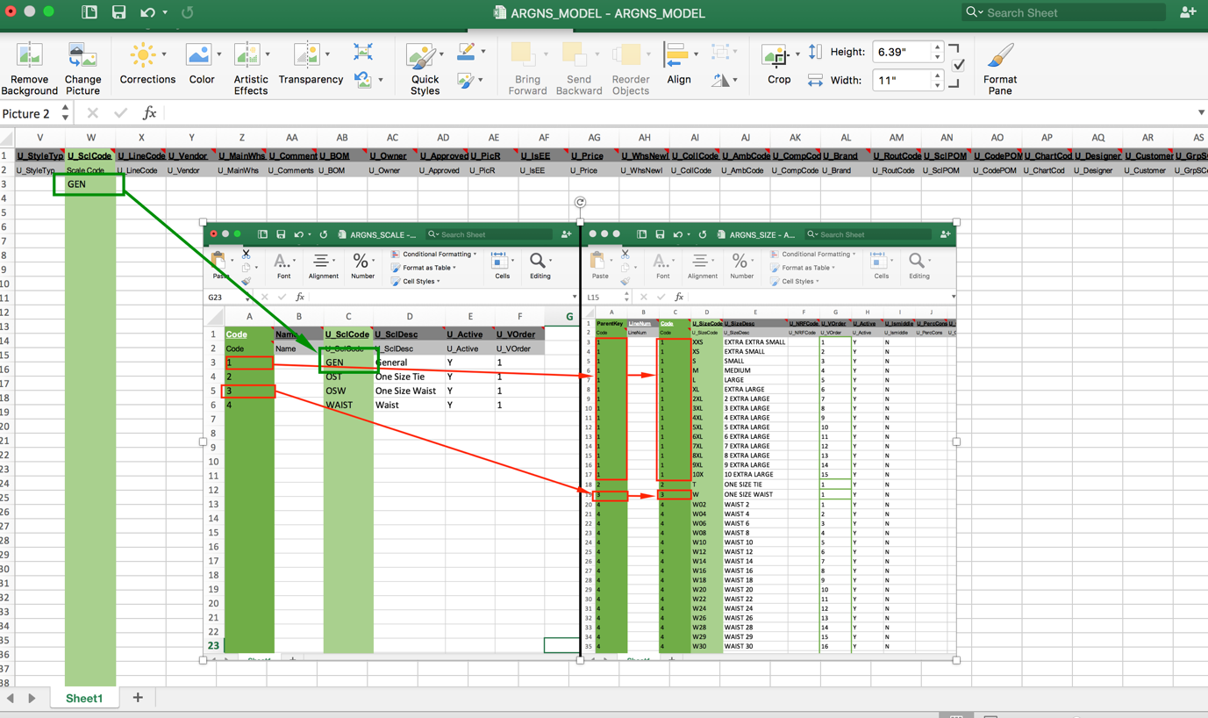

Notes:

1. If you want the style to be active check that the the following column is “Y”

|  |
| --- |
| **U_Active** |
| U_Active |
| Y |

1. If you are going to import OITM – Items through DTW check that the following column is “Y”

|  |
| --- |
| **U_SkuGen** |
| U_SkuGen |
| Y |

In case you are not going to import Items and will create them manually from the Apparel & Footwear PDM clicking on the “Generate SKUs” button, this column should be “N”.

###### Model – Color

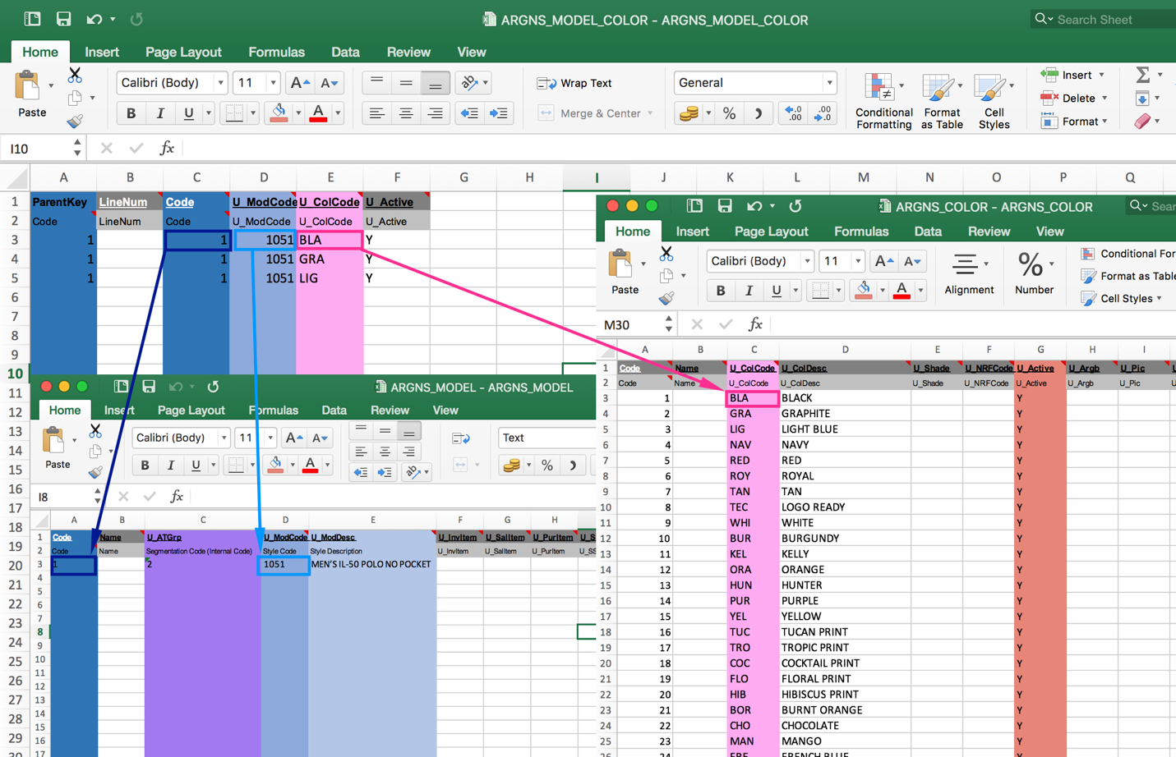

Notes:

1. If you want the style to be have the color active, check that the the following column is “Y” in the ARGNS_MODEL_COLOR - ARGNS_MODEL_COLOR file.

|  |
| --- |
| **U_Active** |
| U_Active |
| Y |

###### Model – Sizes

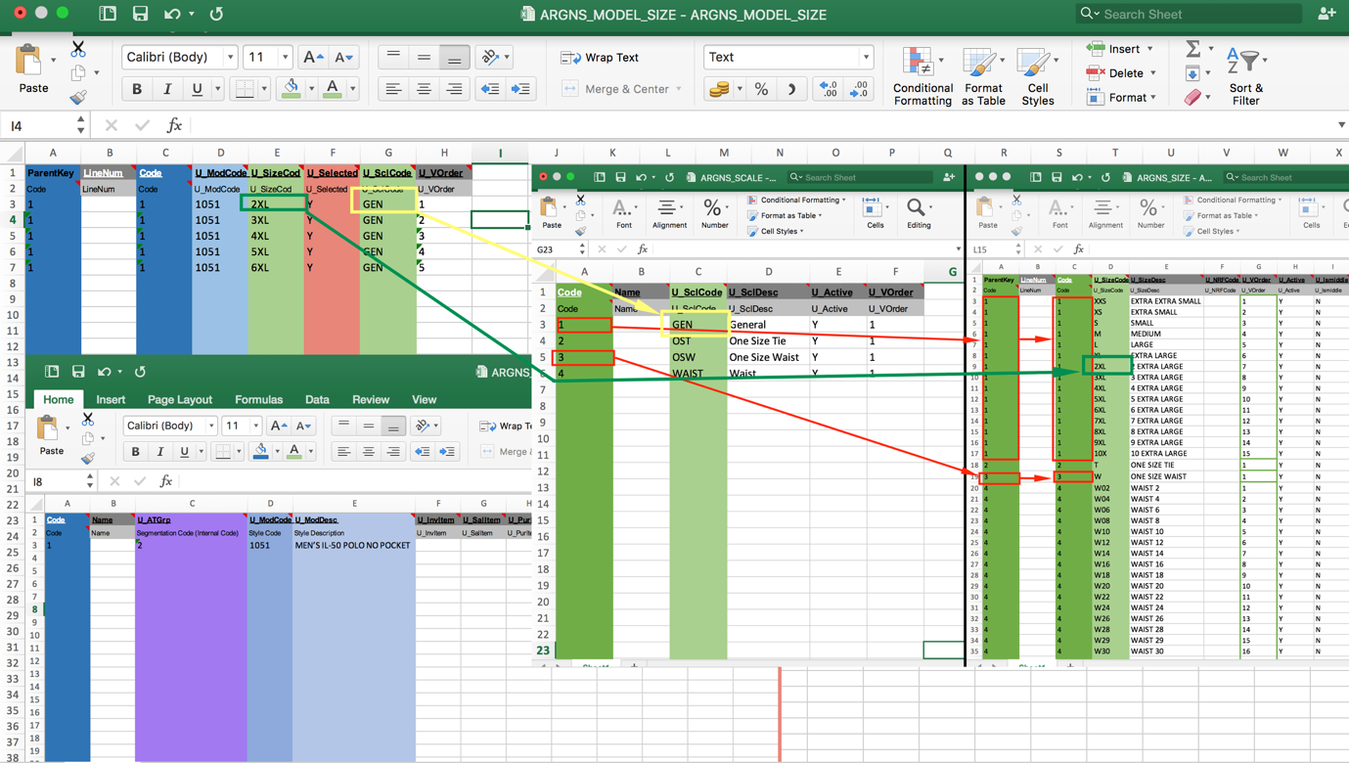

Notes:

1. If you want the style to be have the sizes active, check that the the following column is “Y” in the ARGNS_MODEL_SIZE - ARGNS_MODEL_SIZE file.

|  |
| --- |
| **U_Selected** |
| U_Selected |
| Y |

###### Model – Variable

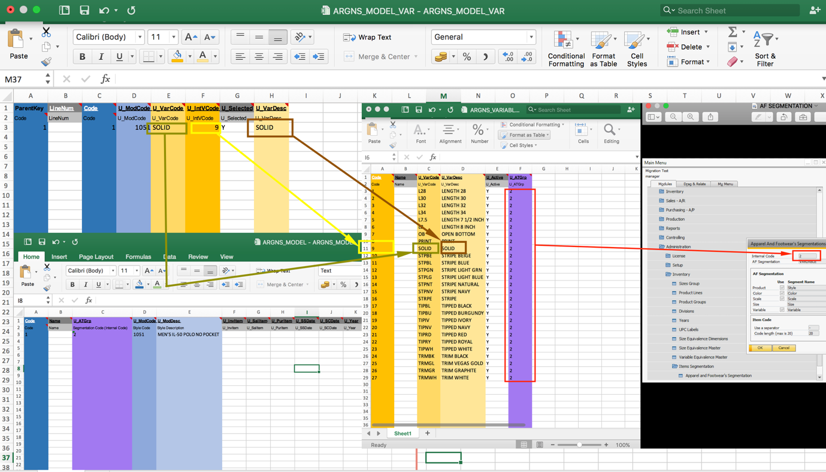

Notes:

1. If you want the style to be have the variable active, check that the the following column is “Y” in the ARGNS_MODEL_VAR - ARGNS_MODEL_VAR file.

|  |
| --- |
| **U_Selected** |
| U_Selected |
| Y |

##### OITM – Items

###### Complete Items Code and Description

The max digits vary according to the segmentation.

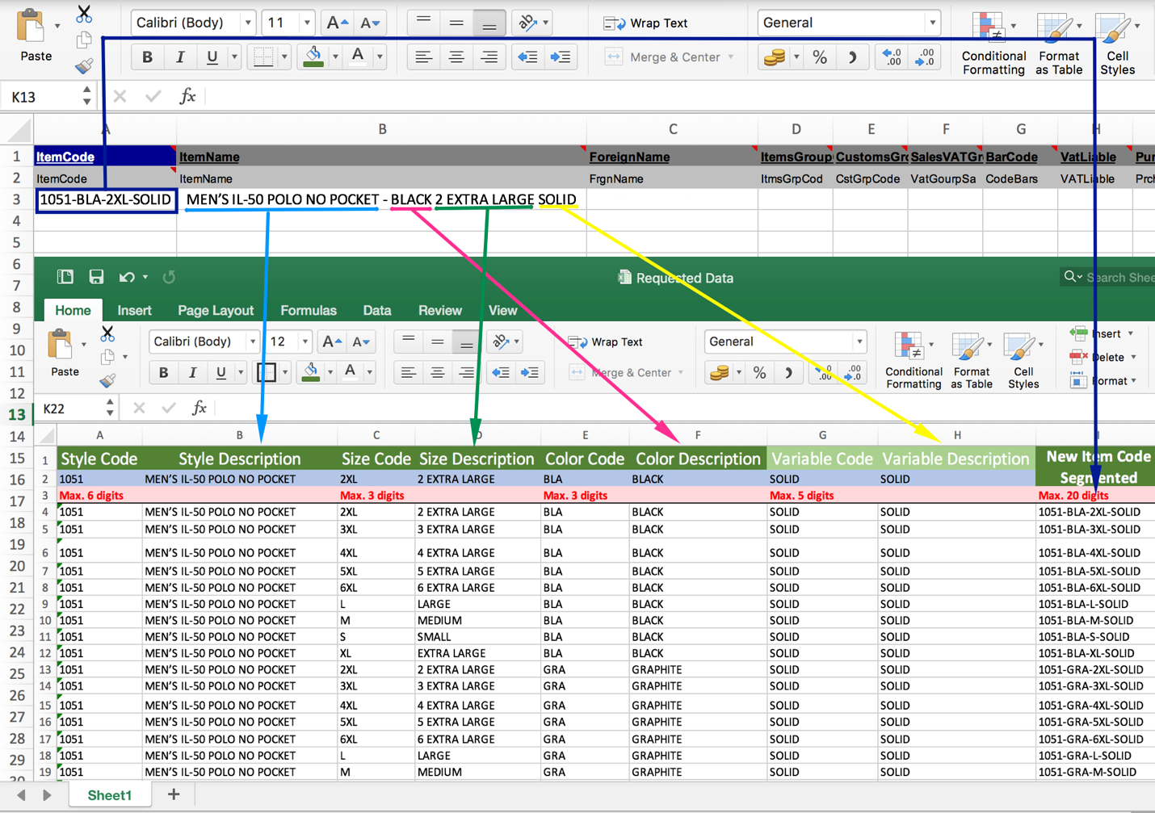

###### Relate Color, Model, Segmentation

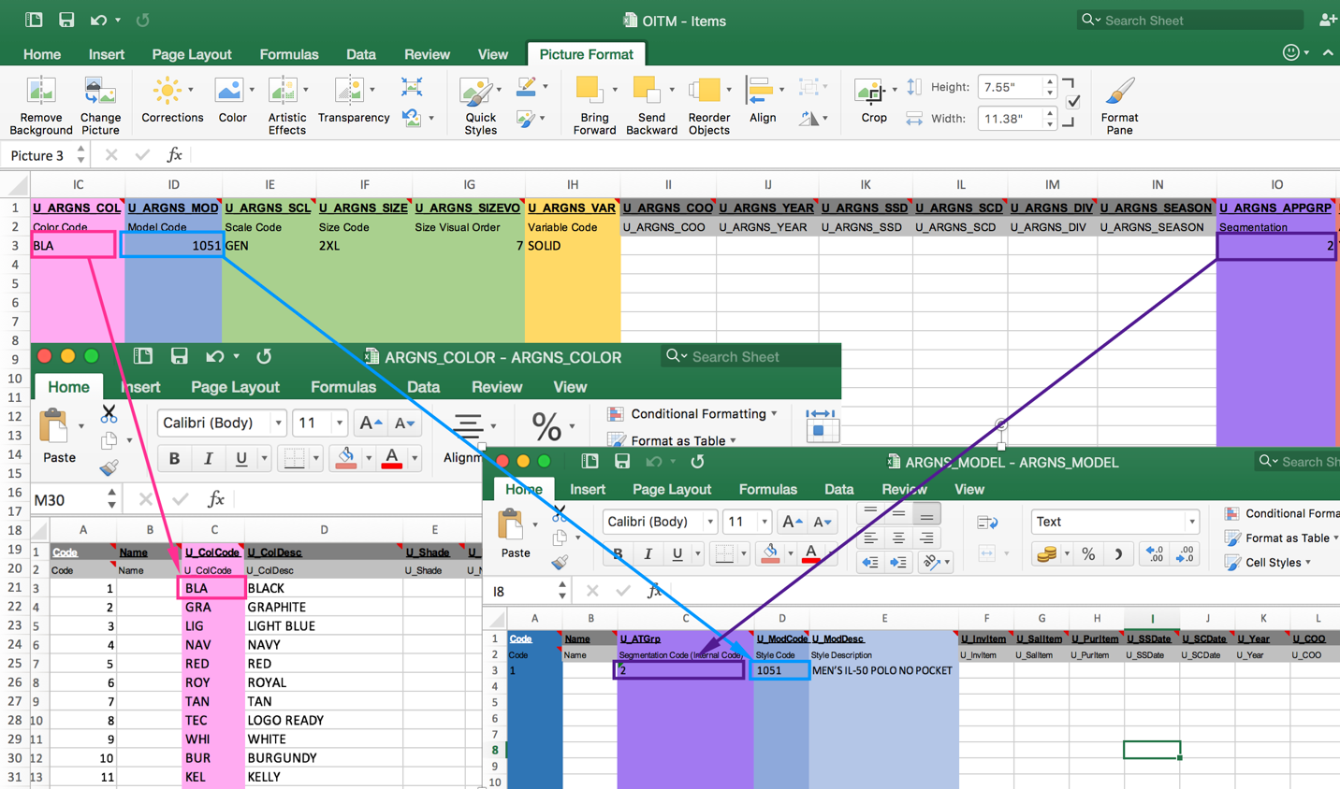

###### Relate Scale, Sizes, Variable

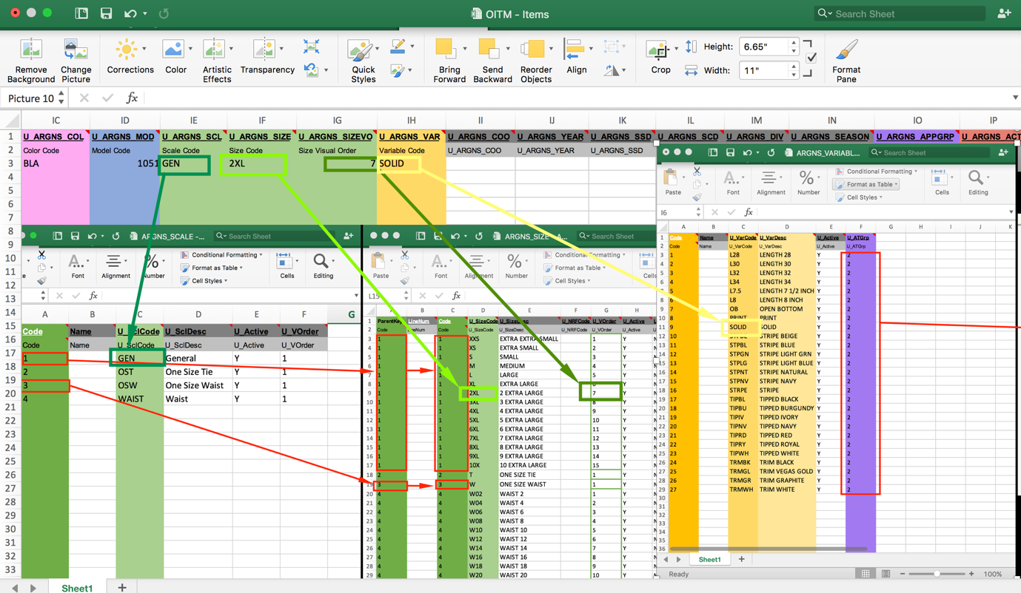

Notes:

1. If you want an Item to be active make sure that the following column is “Y”

|  |
| --- |
| **U_ARGNS_ACT** |
| Active Flag |
| Y |

### CSV files import trough DTW – Data Transfer Workbench

1. Click on the “Import” button to start the Data import wizard
2. Select **Master data** as the data type.

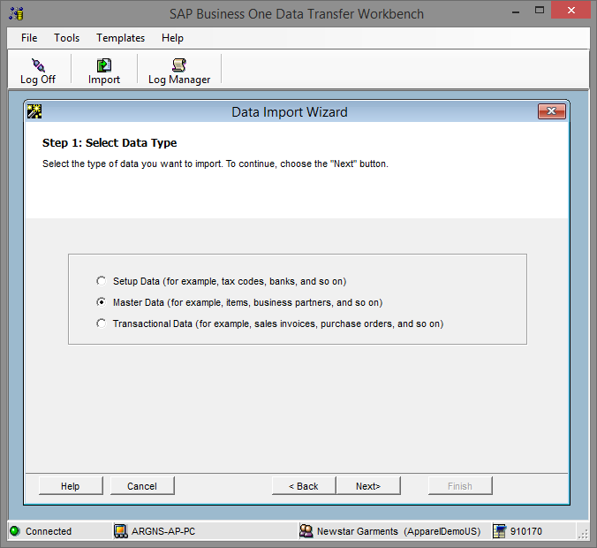

1. Select **Add new data** as the operation type (Please note that if you are working with already existing styles, then select the **Update existing data** option or the **Add new data and Update existing data** if you are going to be updating data and loading new data all in the same process).

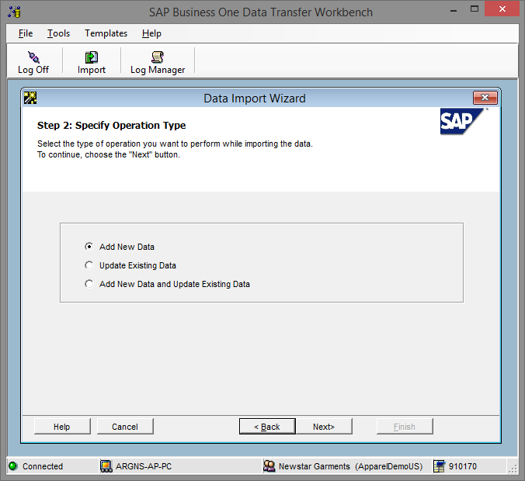

1. Search and select the UDO_ARGNS_MODEL business object under the following path: User Defined Data > Objects (UDO) > UDO_ARGNS_MODEL.

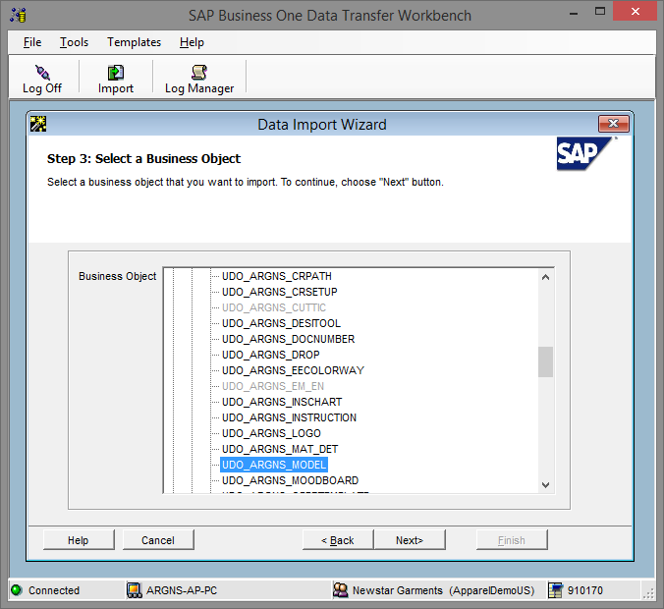

1. Select the templates corresponding to each object. Please note that there are templates which are not necessary to have them filled with data but that must be selected as required by DTW. In this example, the ones within the red square have been added just because the last object to be imported is the Variable (ARGNS_MODEL_VAR) therefore all the objects in between should be mapped to something.

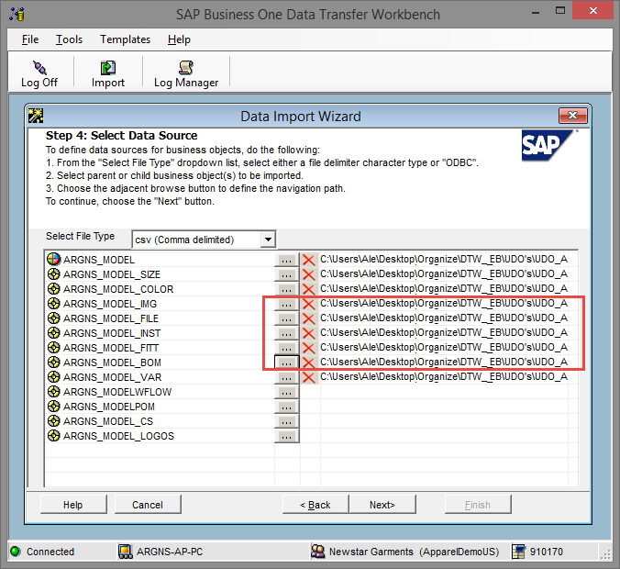

1. Map Object fields. This is a confirmation screen for the data mapping.

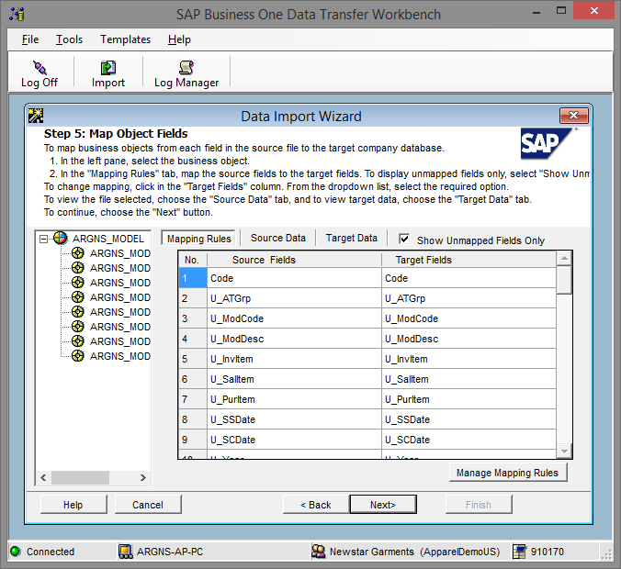

1. Define error handling. It is usually recommended to select the last option to prevent from processing the entire file if a certain number of errors are found. In this step it is usually recommended to run the simulation process (by clicking the Run Simulation button) to get a preview of the data import result.

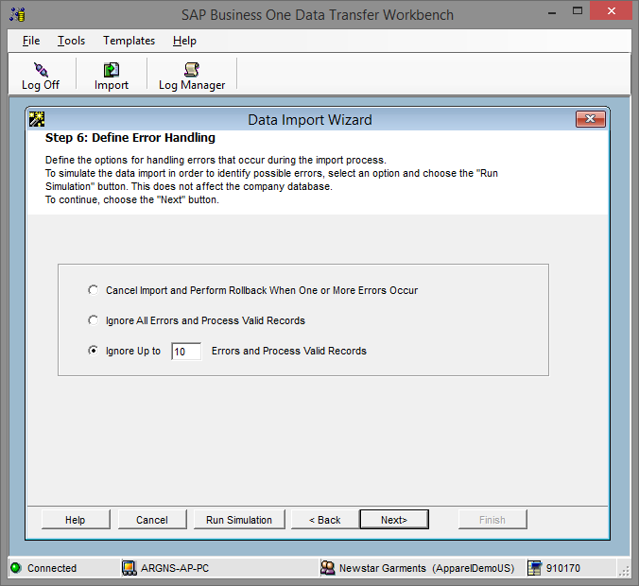

1. Start importing data. If no errors were found in the simulation process, click on the Import button to start the actual data import process. Please not that this does not guarantees that the data imported is accurate and it must be checked within SAP to make sure that everything is being loaded the way it should.



**www.argentisconsulting.com**

**Argentis Consulting** is dedicated to the development, distribution and support of recognized certified solutions for SAP Business One, as an SSP (Software Solution Provider) with a Gold Partner status.

**CONTACT INFORMATION**

|  |  |
| --- | --- |
| **USA**  9744 NW 45th Lane  Doral, FL 33178  info@argentisconsulting.com | **ARGENTINA**  Ávila y Zarate 2048  Cerro de la Rosas, Córdoba,  CP 5009  Córdoba - Argentina  info@argentisconsulting.com |
| **CARIBEAN**  City View Plaza – Suite 301  48 Road 165  Guaynabo, PR. 00968  Puerto Rico  caribe@argentisconsulting.com | **SPAIN**  C/ Juan Bravo N° 3 A 28006  Phone: (+34) 91 123 7263  Madrid - Spain  info@argentisconsulting.com |